**Final Project**

Section: K19KP Project Group No.: 21

Title: Helping Hands

INTERNET PROGRAMMING (CSE-326)

|  |  |  |  |
| --- | --- | --- | --- |
| **Sr. No** | **Registration No.** | **Name** | **Roll No.** |
| 1 | 11919432 | Lalbabu Mandal | 61 |
| 2 | 11910453 | Abhishek | 62 |
| 3 | 11905384 | Kalyan Ji Mishra | 63 |



Submitted To: Mr. Ishan Kumar

**Introduction**

The Project that we have created is “The Helping Hands”.

This website is designed basically to act as a gateway between common people and the authorities. The website is user-friendly and easy to understand.

With the help of this website a person can register their complaints regarding the public inconvenience that they are facing. The complaint can be regarding anything and can be from anywhere. The information and details about the complaint will be used by the concerned authority in the future and appropriate actions will be taken, in order to resolve the issue.

There is a home page in which there are several buttons in the navigation bar like About Us, Gallery, complaint button, Signin button, etc.

Using the complaint button a person can register their complaint. They will have to fill the form where they provide the information about their complaint. So, this is our website all about.

**Role in the project:**

|  |  |  |
| --- | --- | --- |
| Roll no. | Name | Role in the project |
| 61 | Lalbabu | Images collection ,HTML code for About Us page, Synopsis writing. |
| 62 | Abhishek | Content collection,  deciding overall look of the project, HTML code for writing for complaint page.  Final report(half) |
| 63 | Kalyan | HTML code writing for Home Page, Gallery, CSS code, Final Report(Other half). |

**Tags used in the website**

1. **<div>**

<div class="button">

<a href="myweb2%20gallery%20complaint.html" class="btn">Gallery!</a>

<a href="myweb2%20about.html" class="btn">About Us</a>

</div>

2. **<nav>**

<nav id="navbar">

<ul>

<li><a href="Main Page.html">Home</a></li>

<li><a href="complains history1.html">Previous Complaints</a></li>

</ul>

</nav>

3. **<img>**

<img src="hann.png">

4. **<link>**

<link rel="stylesheet" type="text/css" href="styles.css">

5. **<script>**

<script src="submitmessage.js"></script>

6. **<label>**

<label for="fname">First Name</label>

7**. <form>**

<form action="/action_page.php">

<label for="fname">First Name</label>

<input type="text" id="fname" name="firstname" placeholder="Your name..">

<label for="lname">Last Name</label>

<input type="text" id="lname" name="lastname" placeholder="Your last name..">

.

.

.

</form>

8**.<a>**

<a href="Main Page.html">Home</a>

9**. <ul>**

<ul>

<li>

<a href="myweb2%20gallery%20complaint.html">Gallery</a></li>

<li>

<a href="myweb2%20complaint%20page.html">Complaint</a></li>

<li><a href="myweb2%20donate.html">Donate</a></li>

<li><a href="myweb2%20login%20page.html">Sign in</a></li>

</ul>

**Screenshots from the website**

**Home page**



**Complaint Page**

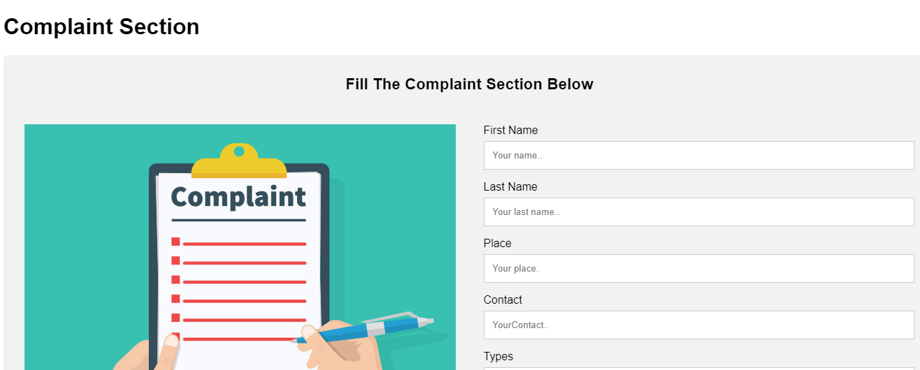

Complaint Gallery



About Us

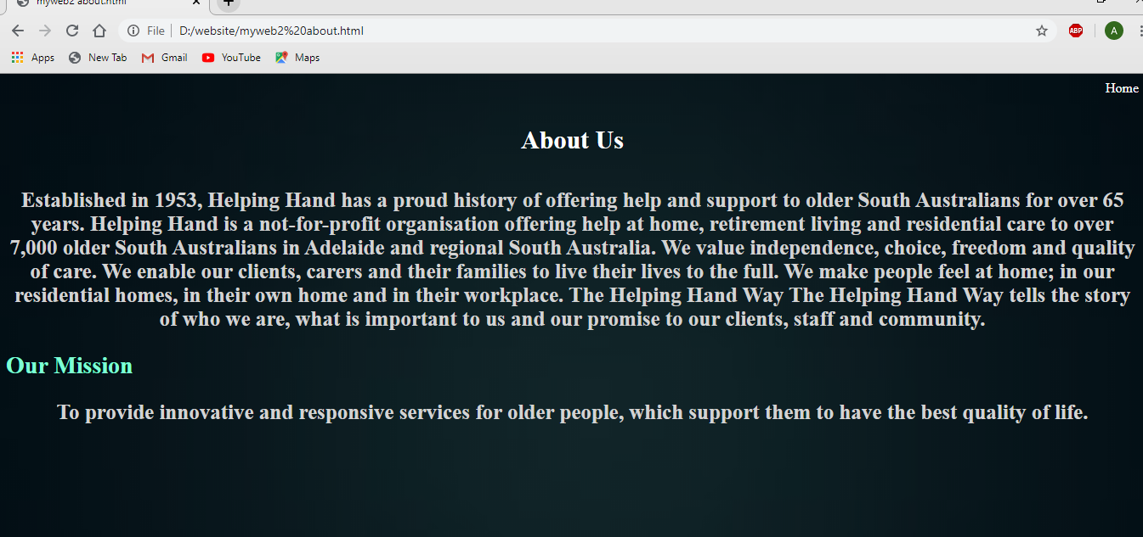

Login Page

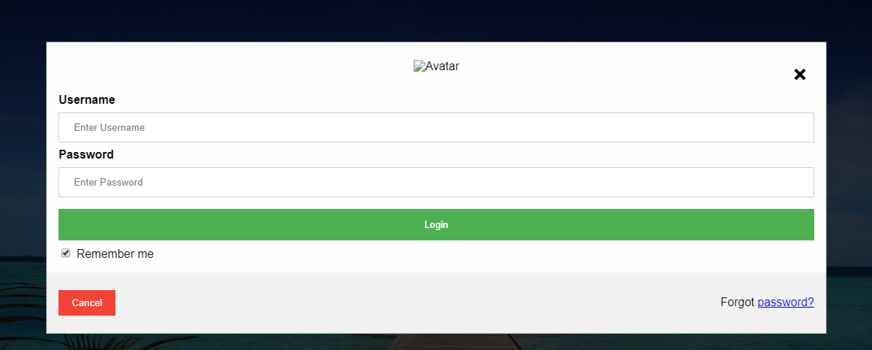

Donation Section Page

